**Addendum**

**All child poverty figures are from** Central Statistics Office, Survey on Income and Living Conditions (SILC) 2024 (CSO 2025*).*

**Consistent Poverty**

Consistent poverty occurs when an individual is experiencing both income poverty and enforced deprivation. The Roadmap for Social Inclusion policy set a target to reduce consistent poverty to 2% by 2025. This will not be achieved as CSO SILC data we have for 2024 shows:33

Consistent poverty rate for children of one-parent families is 11%, almost double that the rate for children of two-parent families; a 4% increase since 2023.

One-parent families experienced the highest consistent poverty rate of all households in 2024.

**Deprivation**  
Deprivation occurs when households are unable to afford certain goods and services considered the norm for society and essential for a minimum standard of living.

The national deprivation rate in 2024 stood at 15.7%, from 17.3% in 2023.

The deprivation rate for lone-parent families is 46.3% compared to 41.4% the year before.

One-parent families experienced the highest deprivation rate of all households in 2024.

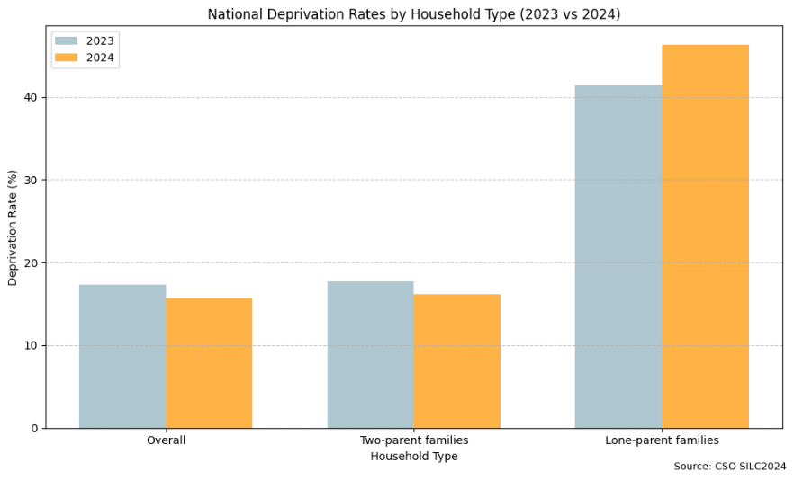

**At Risk of Poverty Rates**

People can be described as ‘at risk of poverty’ (AROP) or ‘income poor’ where income falls below a certain threshold, specifically 60% of the national median income which is adjusted annually by the CSO.

The national at risk of poverty rate in 2024 stood at 11.7%.

The rate for lone-parent families was 24.2% compared to 19.2% in 2023 and nearly double the rate of two-parent families.

Children and young people are the most ‘at risk of poverty’ when looking at poverty metrics based on age. 15.3% of all children live in households experiencing income poverty, which is much greater than for the general population which stands at 11.7%.

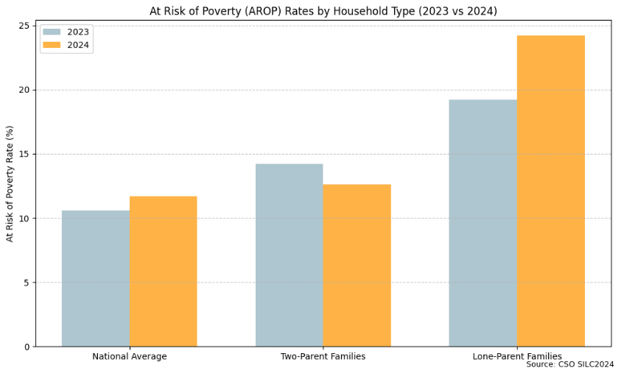

**At Risk of Poverty After Housing Costs**

At risk of poverty rate after housing costs is defined as households whose disposable income after subtracting rent and mortgage interest payments, falls below 60% of the national median income. These are households whose incomes are low enough to be considered ‘at risk of poverty’ or ‘income poor’, even after they have paid their housing costs.

The rate of households who are at risk of poverty after housing costs:

Two-parent families – 20.3%

Lone-parent families – 50.4%

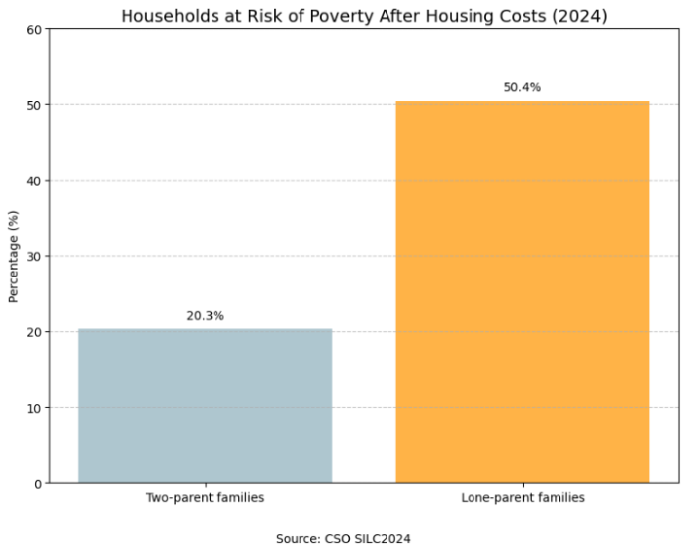

The At Risk of Poverty after Housing Costs based on tenure is:

Homeowners – 7.9%

Tenant in private rental market – 40.6%

Tenant in Social Housing provided by Local Authority/AHB – 43.3%

Tenant in receipt of a Social Housing Support Payment - 57.4%.

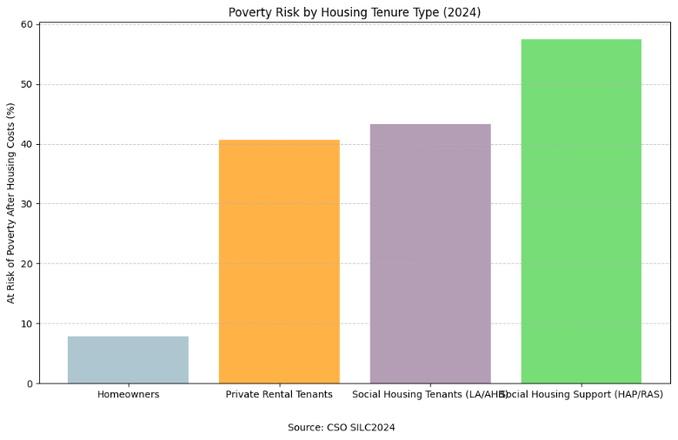

### **Minimum Essential Standards of Living Data**

The most recent Vincentian MESL Centre data tells us that social welfare payments are not at a sufficient level to cover the cost of an essential basket of goods and services. Economically vulnerable households in receipt of social welfare therefore experience greater levels of income poverty, deprivation and social exclusion.

A lone parent headed household whose income comes from social welfare payments and who has two children (one age 7 or older in primary and one age 12 or older in second level) are short by €102 every week if living in an urban area or by €203 if they are rurally based.34

