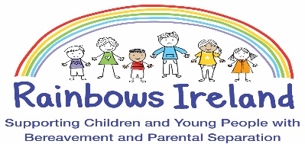
Expression of Interest Form
(Pillar Project – Pilot Rainbows Programme via Zoom)

Name of child/young person: __________________________________________________
Date of birth: ______________________________________________________________
Home address: ______________________________________________________________
Date:

Parent/Guardian name: ______________________________________________________
Parent/Guardian mobile number: ______________________________________________
Parent/Guardian email address: _______________________________________________
It is necessary for us to collect Dual Consent – so the second parent – if they are a legal guardian will be asked to consent in the registration process.

Date of Expression of Interest: __ _______________________________________________

Please complete this form and
Email it ask@rainbowsireland.ie or post to Rainbows Ireland, Loreto Centre, Crumlin, Dublin 12 K753
Any further questions about the Rainbows service, please email ask@rainbowsireland.ie or phone Anne: 087 6436748
Thank you for your completing this Expression of Interest form.

